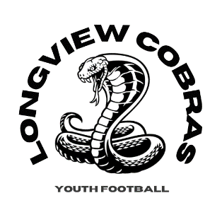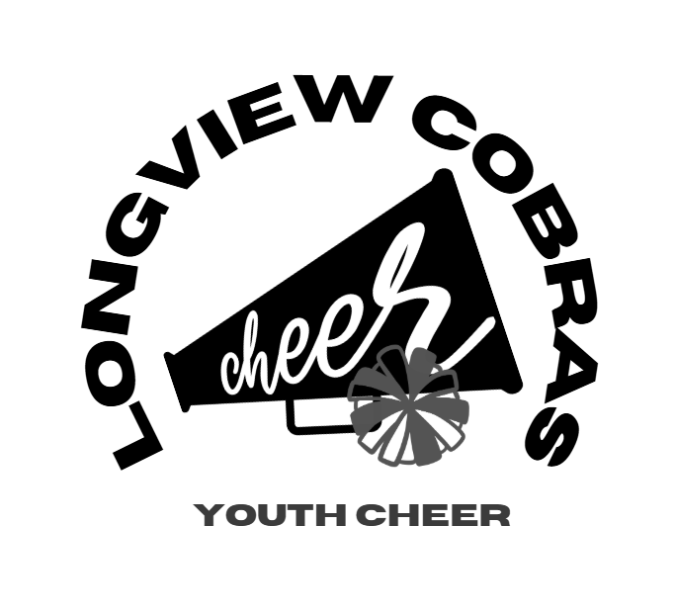
Refund Policies
Following are Lower Columbia Youth Football-Longview Cobra’s refund policies for football and cheer.
Cheer:
Cheer Registration fees are $100 which includes uniform kit and Poms. Fees for registration without uniform kit are $200.
- Participants who quit before September 1st are eligible to receive a partial refund of the Registration fee of $50. Uniform fee is non-refundable once purchased in May/June.
- Participants after September 1st are not eligible for any refund as season has officially started and uniforms and gear have been purchased.
Football:
Registration fees for tackle football are $200 Registration fee with an additional $100 equipment deposit (refunded at gear turn in at the end of the season); $80 for Flag Football.
Players who quit and are eligible to receive a refund if:
- A full refund of the registration fee of $200 will be granted only if the Participant requests it prior to the first official practice session ending. (Day 5 of first official week of practice).
- After the first official practice session, players who quit will not be eligible for registration refunds. This will not be issued under any circumstances as of day 6. (Unless an injury, please see injury info below).
- Equipment fee in the amount of $100 will be refunded once all gear is turned back in.
Injuries:
Players who suffer a season-ending injury may be eligible for a partial refund. To be eligible, the injury must have occurred in a LCYF-sanctioned football practice or game and must be confirmed by an injury report from the head coach. For all season-ending injuries, even those that can be verified by an objective source such as a broken bone that requires a hard cast and/or crutches, a letter from a physician is required.

